7/12/2023

Chakradhar Bhogapurapu, BIBA.

JOINS

INNER JOIN, LEFT JOIN, RIGHT JOIN, FULL JOIN

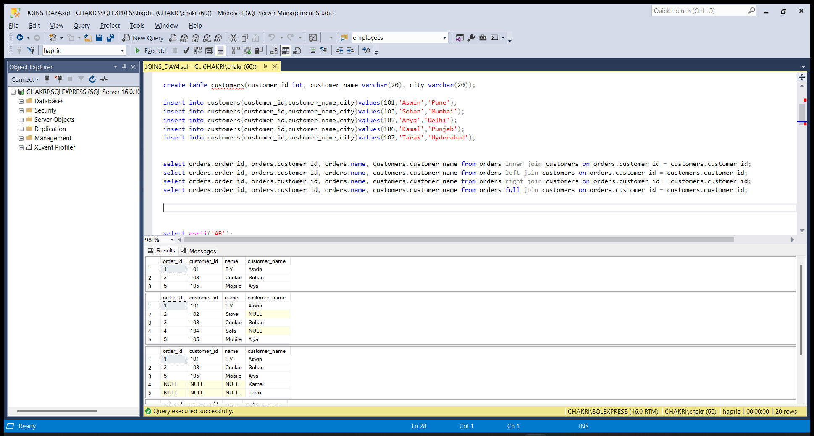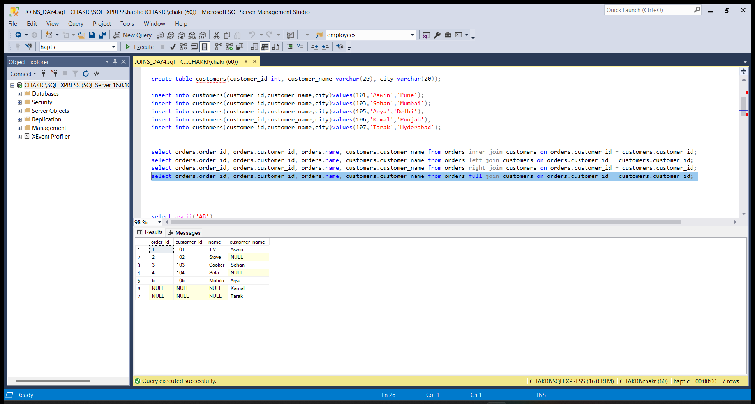

STRING FUNCTIOS

ASCII(), char(), len(), lower(), replace(), reverse(), str(), upper()

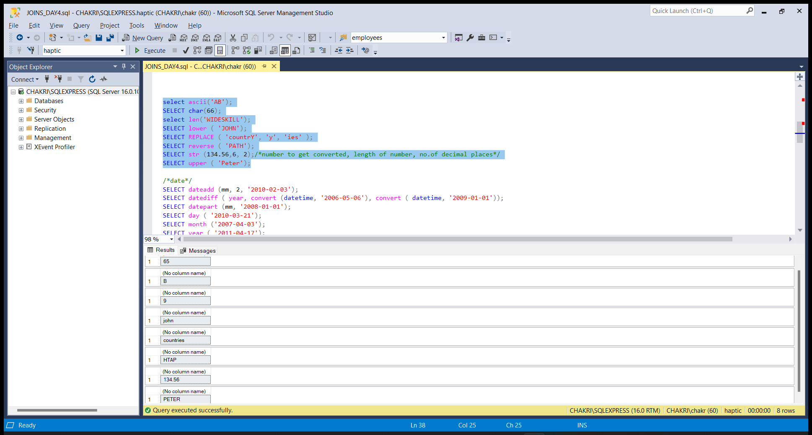

DATE FUNCTIONS

dateadd(), datediff(), datepart(), day(), month(), year()

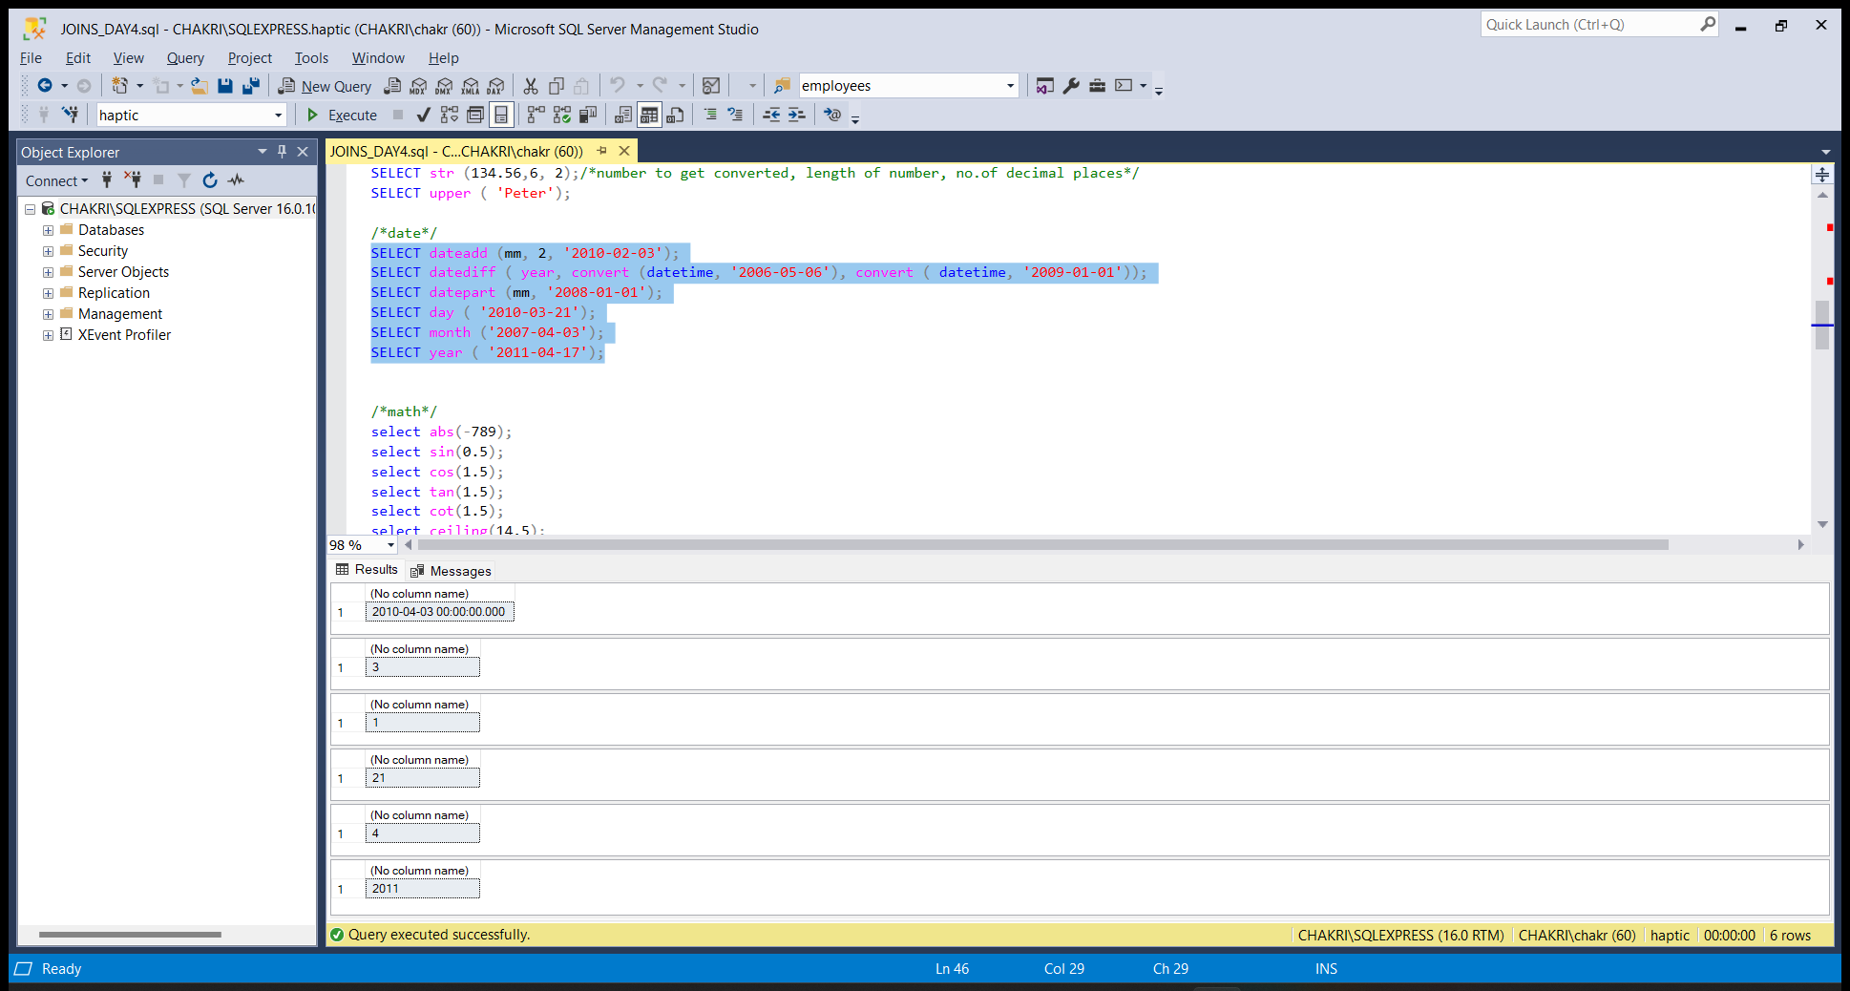

MATHEMATICAL FUNCTIONS

abs(), sin(), cos(), tan(), cot(), ceiling(), floor(), exp(), log()

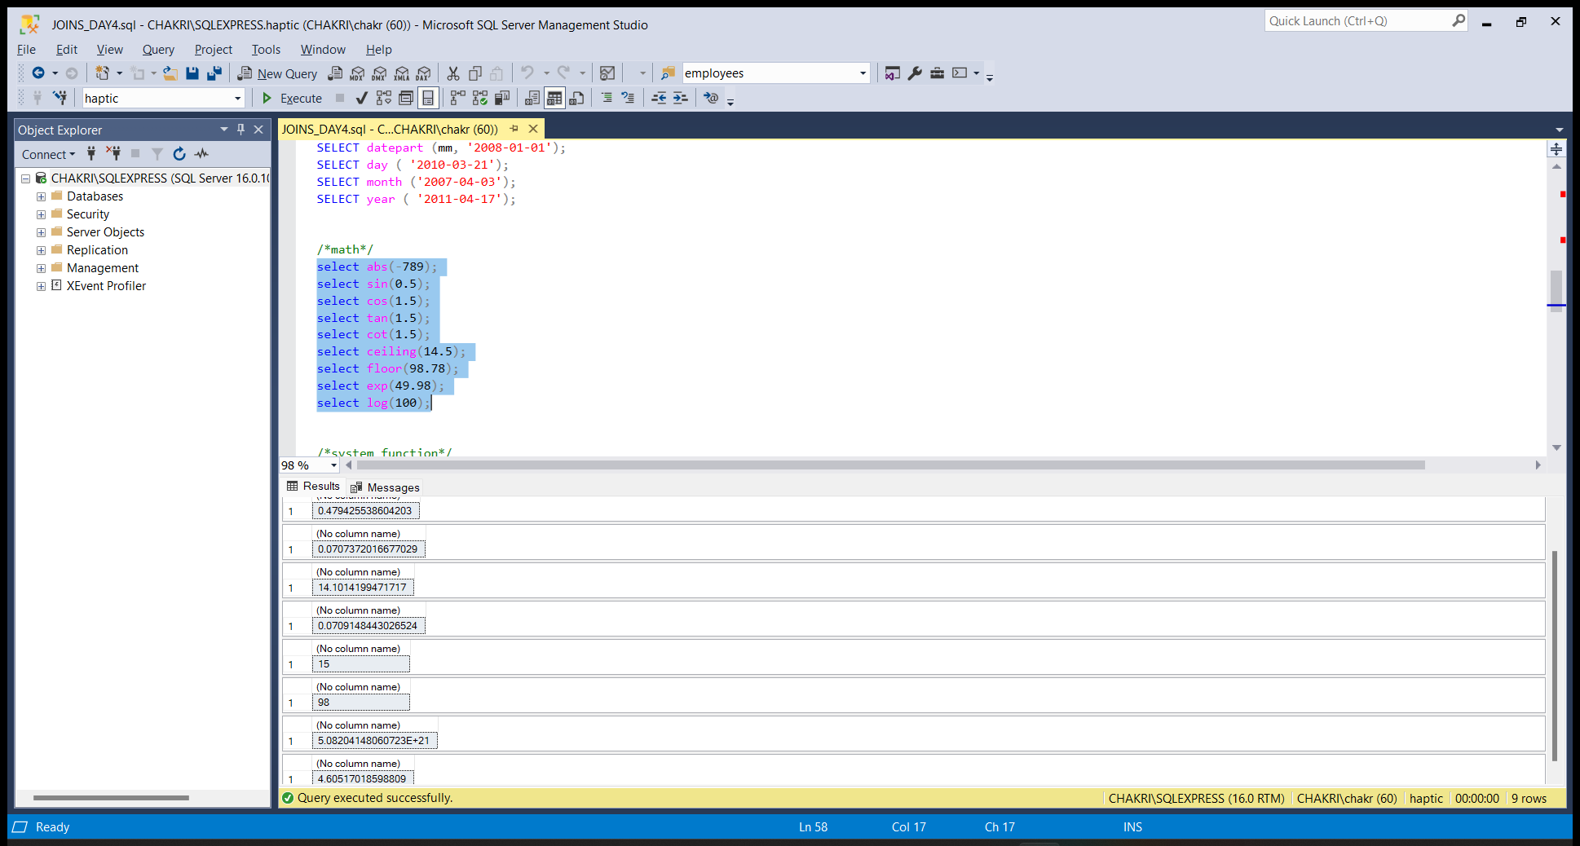

System Functions

HOST_ID(), HOST_NAME(), suser_id(), user_id(), db_name()

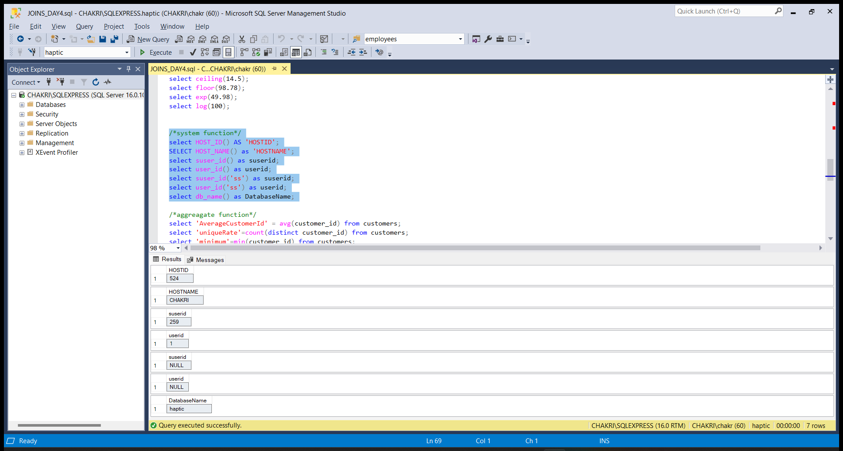

Aggregate Functions

avg(), count(), min(), max(), sum()

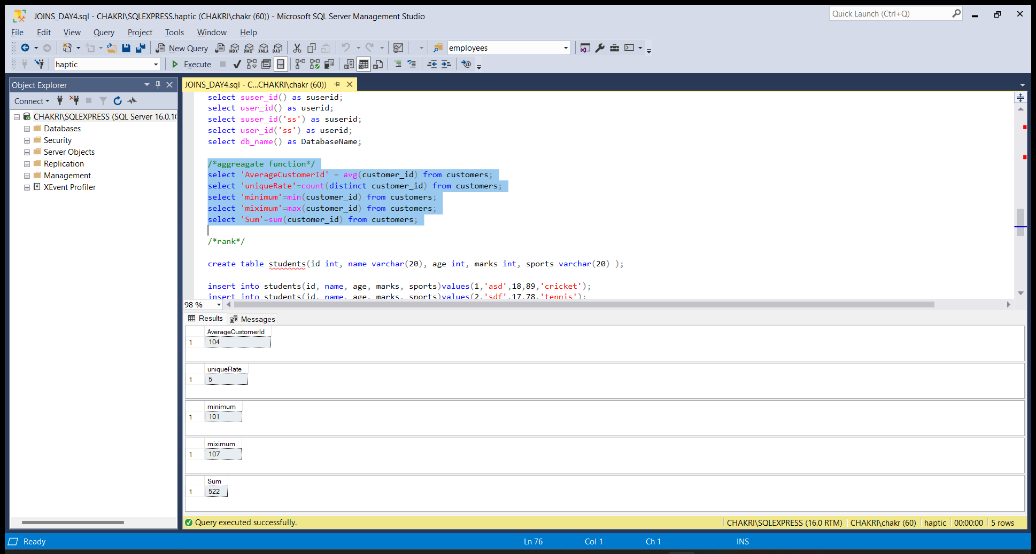

Rank Functions

rank()

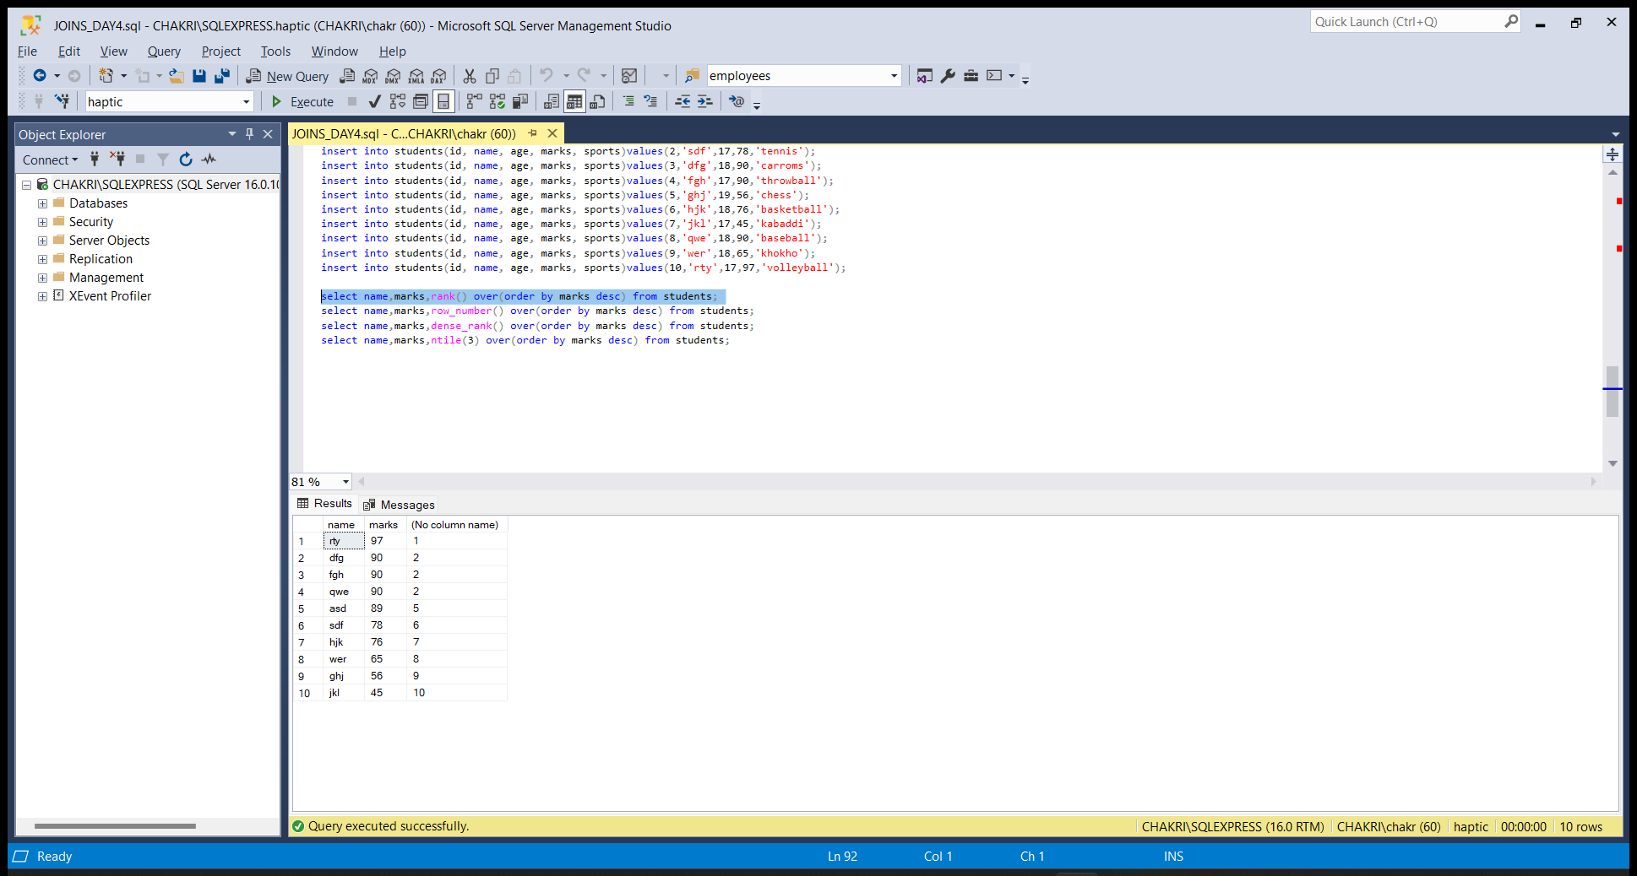

row_number()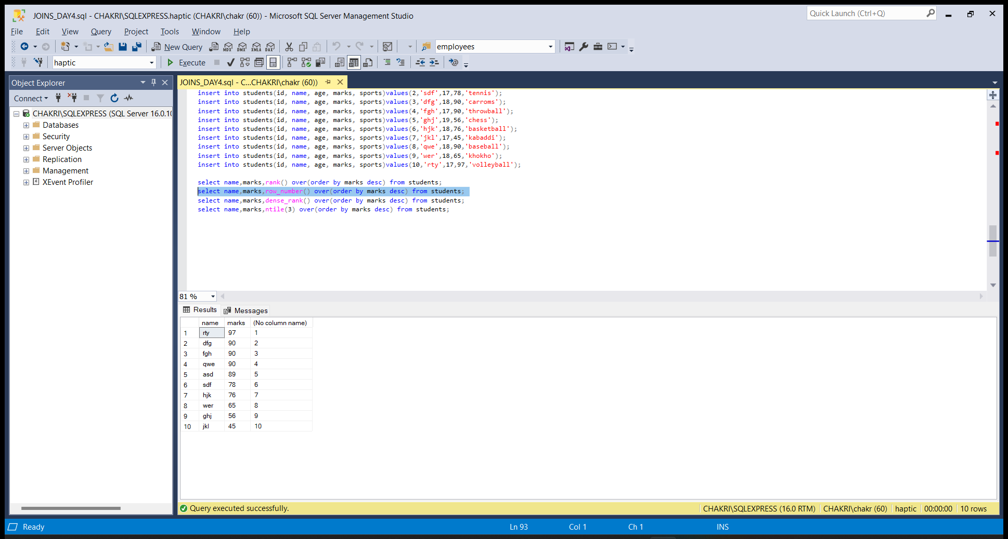

dense_rank()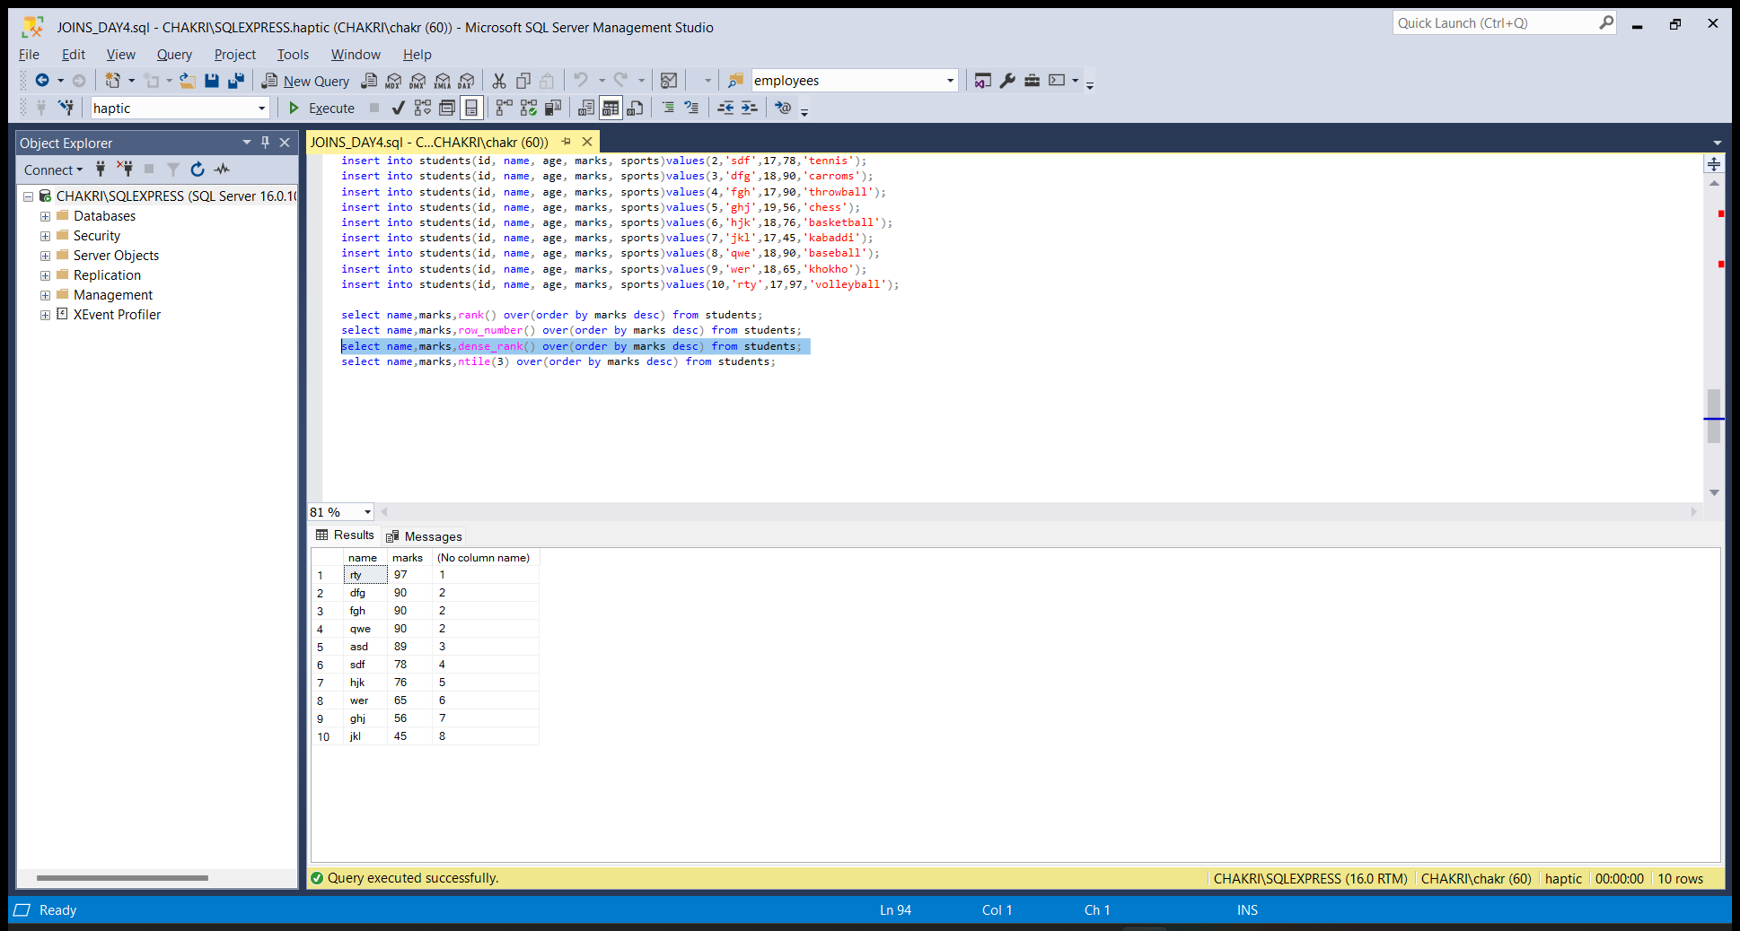

ntile()

